“**Number Conversion Tool”**

Course Title : Structured Programming Lab

Course Code : CSE 104

Group Member:

Student Name : Sultana Razia Faria

Registration : 20101039 (A2)

Student Name : Nafis Sadique Ayan

Registration : 20101042 (A2)

**Reporting To:**

Imran Bin Azad

Assistant Professor

Department of Computer Science & Engineering

University of Asia Pacific

**“Motivation”**

The motivation behind this project was to make a base to base number convertor tool with some other extra features. All this has been done in C programming language.

**“Features”**

In this tool we added any to base to any base convertor which include base-2 to base-16. And also we have 2’s Complement, binary operation & long arithmetic summation.

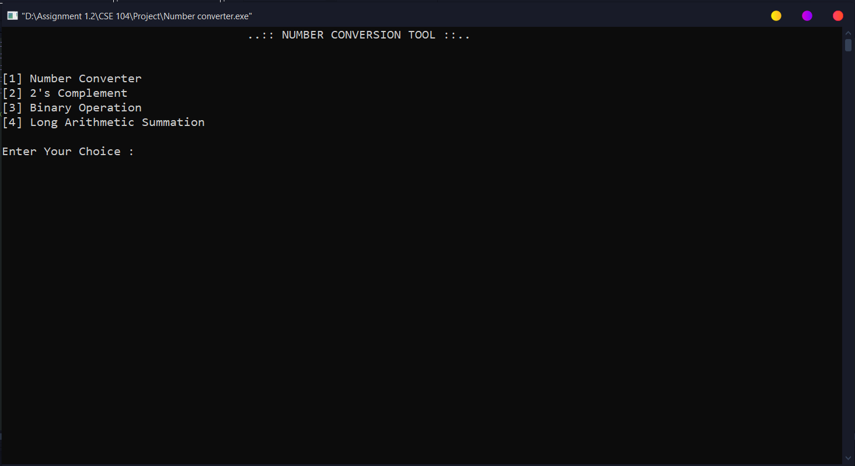

**Number Convertor:** Here we can do any base to any base number conversion as we want. First it will take the base of inputted number then the base we want to convert and lastly the number itself.

Noted: It is limited between base-2 to base-16.

As an example: (56)7 which is (2D)14

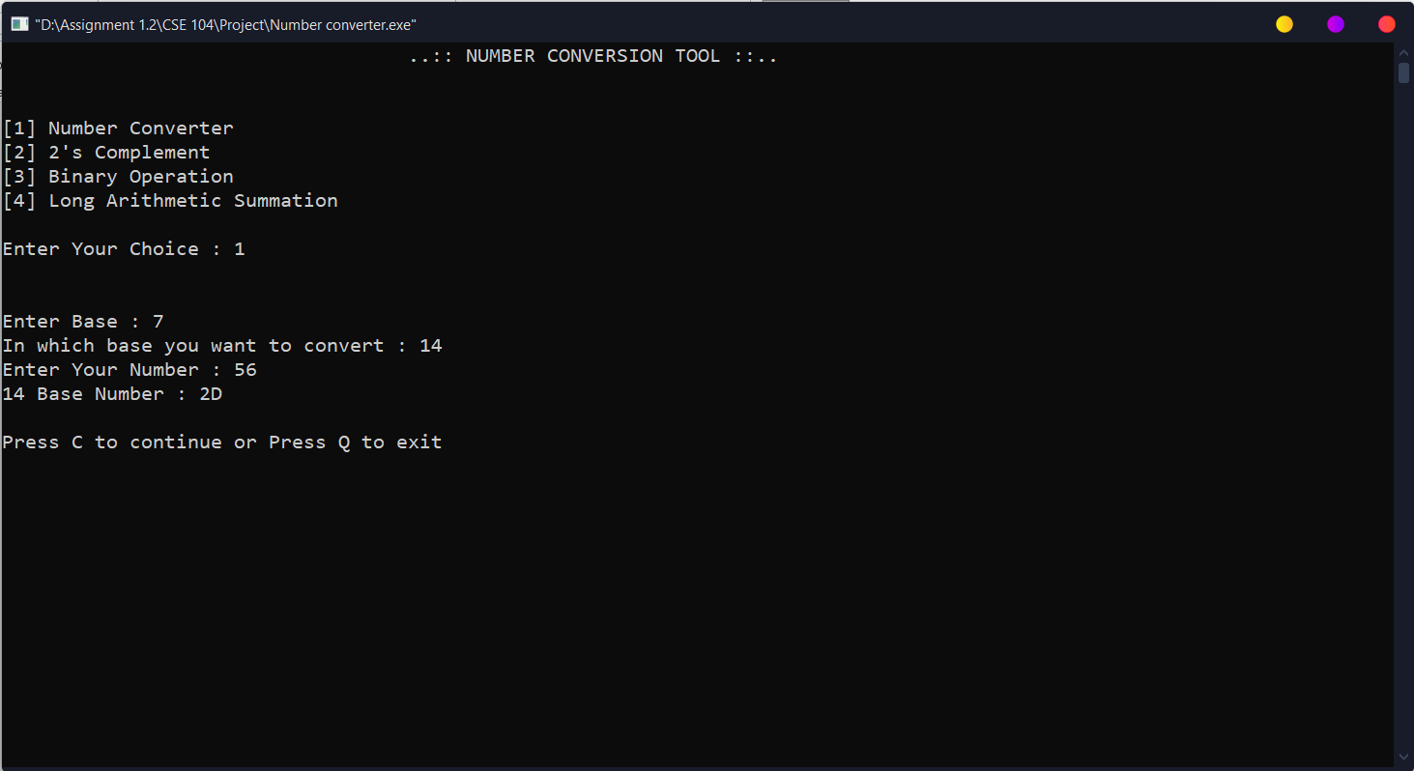

**Special Feature:** “A feature to continue this tool where if we press C the tool will continue and if we press Q the tool will exit”

“And also if we press wrong key it will show ‘Invalid Entry, Try again‘ and we will be able to enter again”

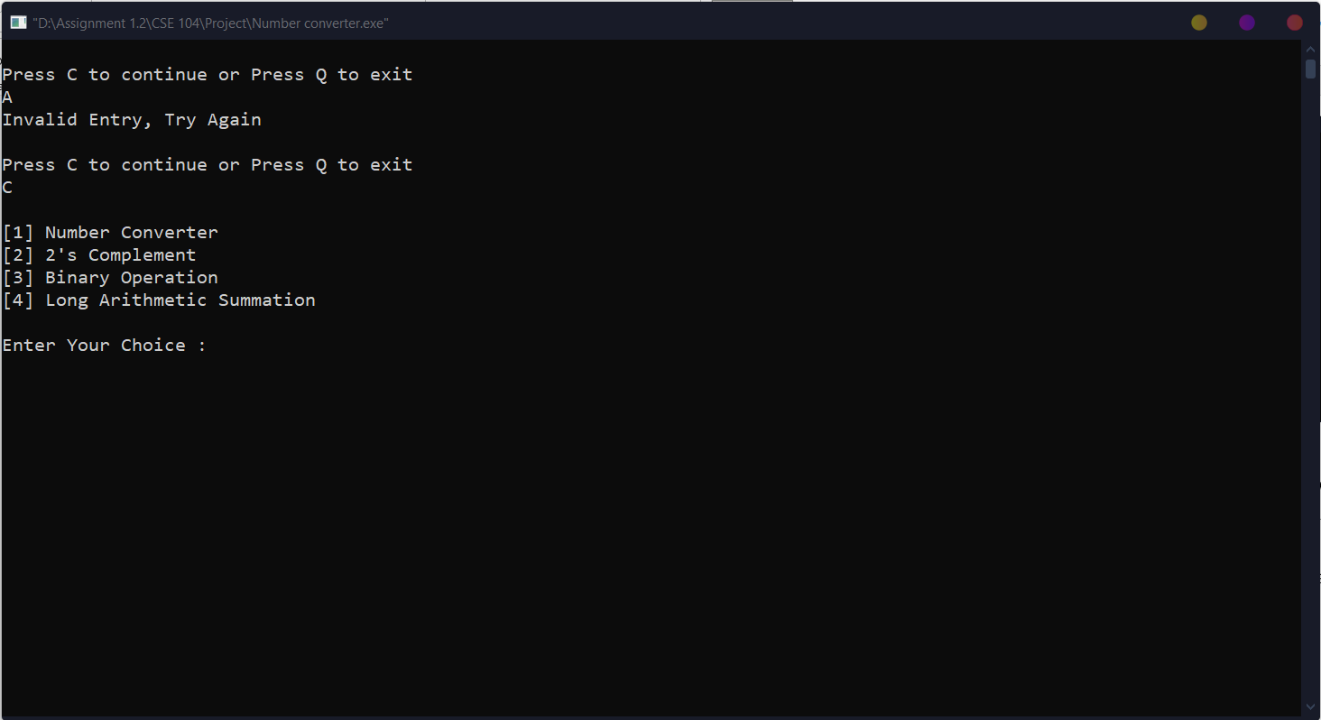

**2’s Complement:** Here we can do 2’s complement of any binary number. First we have input the number of bits then the number itself.

It will show the result of 2’s complement of that binary number following the 1’s complement too.

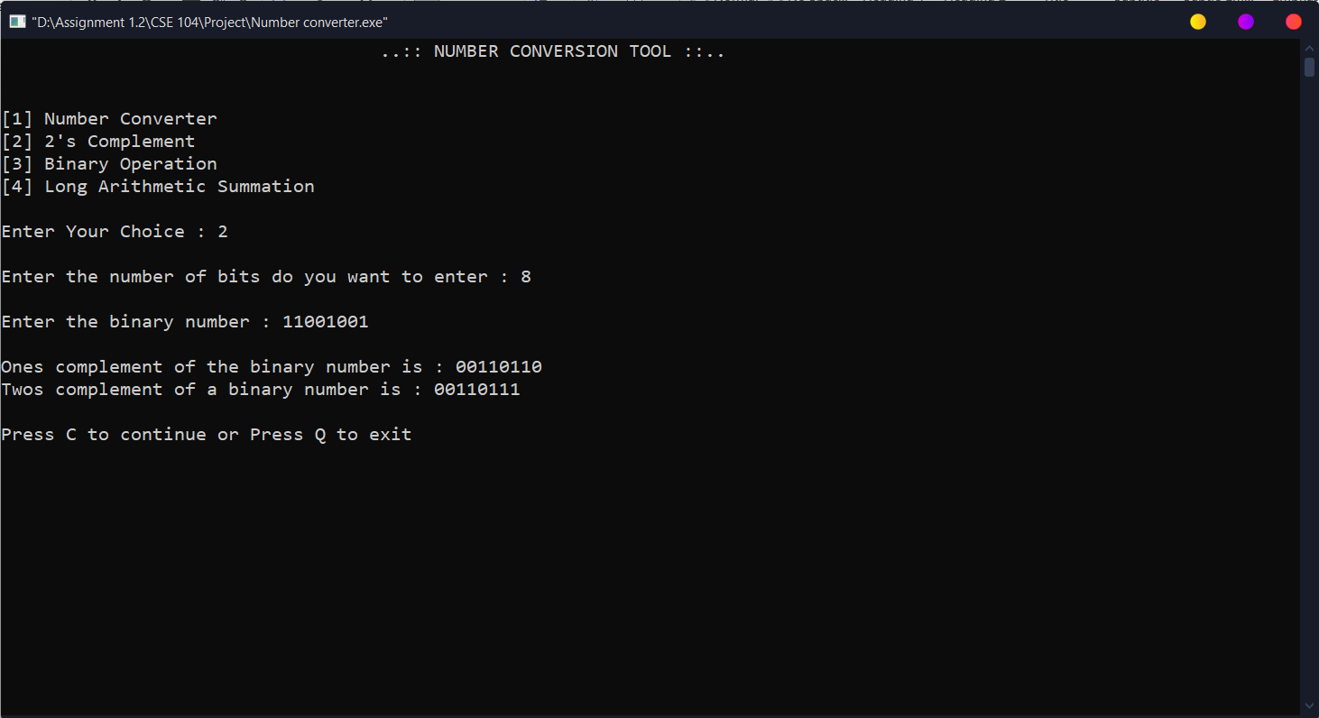

**Binary Operation:** Here in Binary operation we have all six binary operation. Bitwise or, Bitwise and, Bitwise xor, complement, left shift & right shift.

First we will enter two number in the case of or, and, xor binary operation. It will show the output.

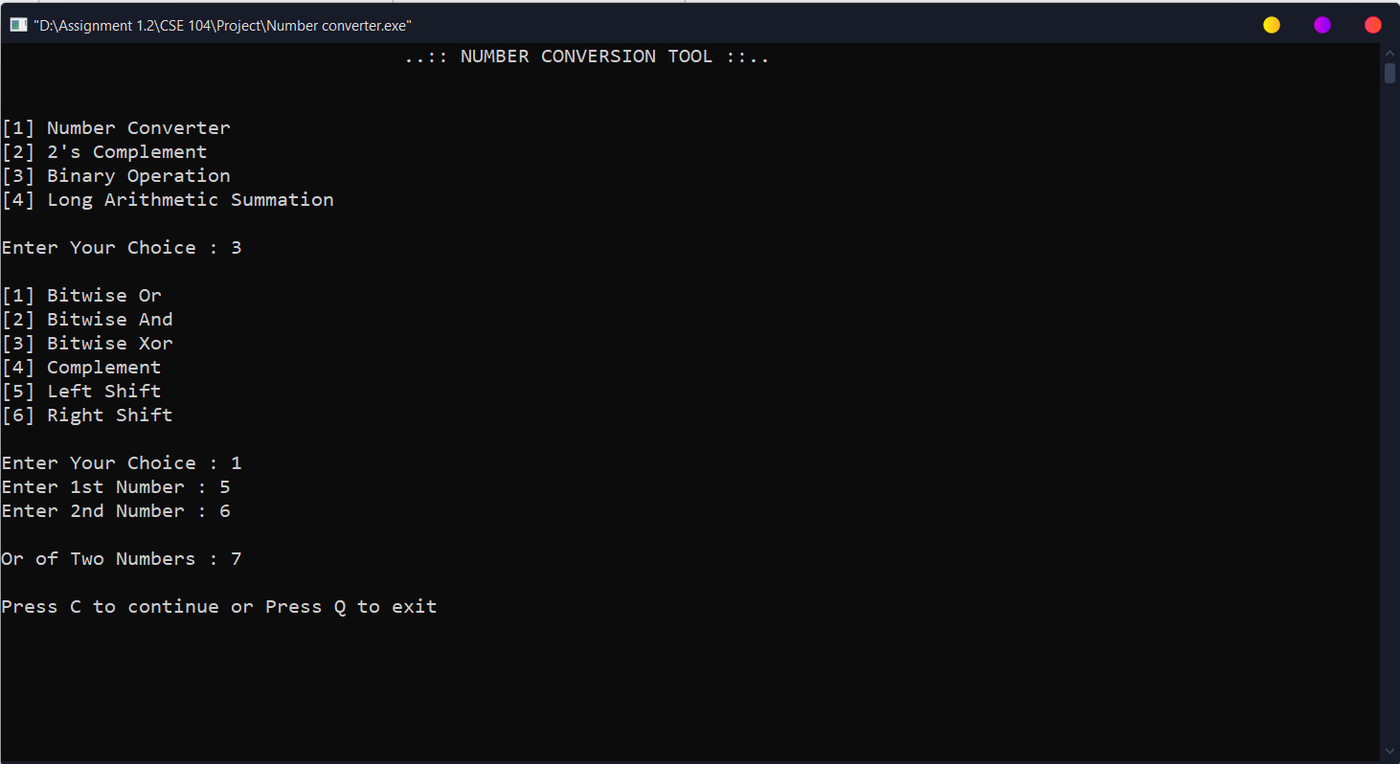

In complement, left shift, right shift we will enter one number and it will show output. In both shift case we also have to input the number of bits we want to shift and here we called in a feature where it will show shift from 0 to the number, we want this to shift.

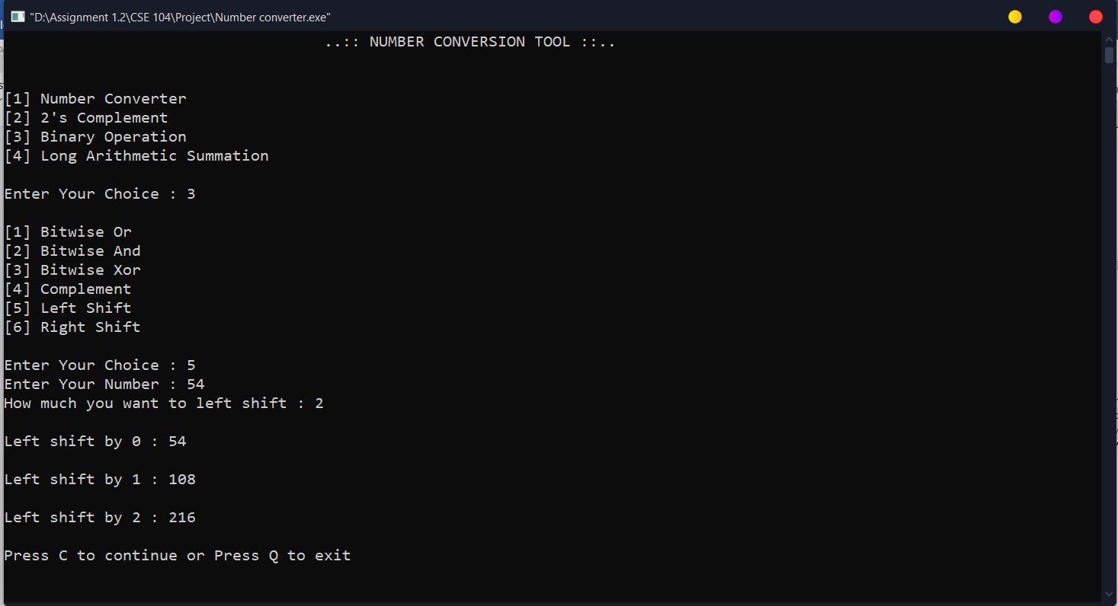

**Long Arithmetic Summation:** Here we will input two very long numbers. It is greater than long long integer. The maximum character string size is 64,000. The string size we used in our program is 10,000.

That’s why we have to do this summation via string and using ASCII values of the number itself.

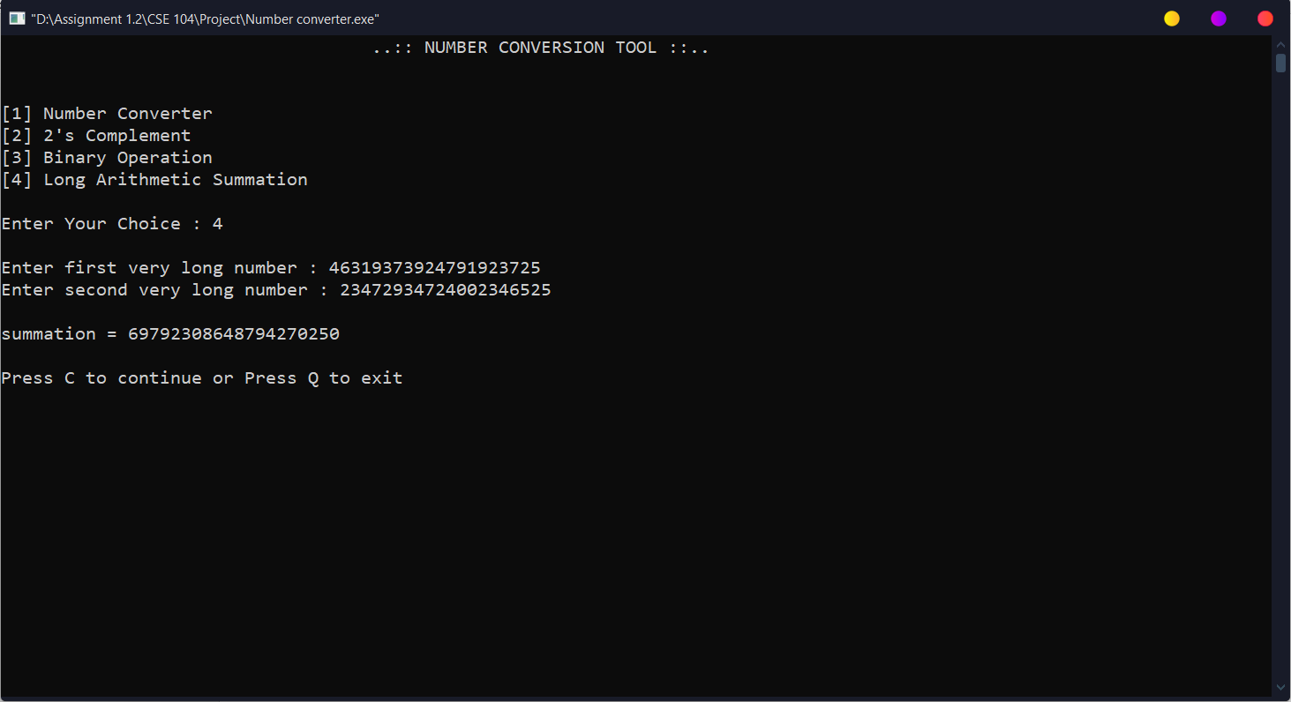

**Tool Evaluation:** We had a feature that we said was to continue and exit with the following C and Q key. If we press Q it will exit the program but it will also ask us to rate the tool between Excellent, Average and Poor. After we evaluate our conversion tool, it will thank us and will close the program.

